4. String Manipulation

Table of Contents

|  |  |  |
| --- | --- | --- |
| Sl. No | Topics | Page No |
| 4.1 | **Sequences** | **2** |
| 4.2 | **String Manipulation** | **5** |

## 4.1 Sequences

**What are Sequences?**

Sequences are containers with items that are accessible by indexing or slicing.

The built-in *len()* function takes any container as an argument and returns the number of items in the container

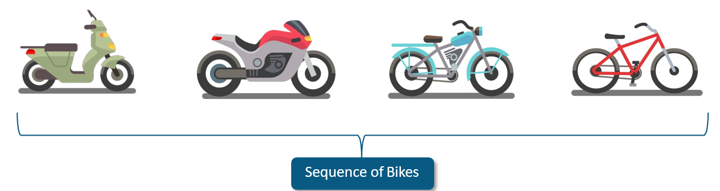

**What are Sequence Operations?**

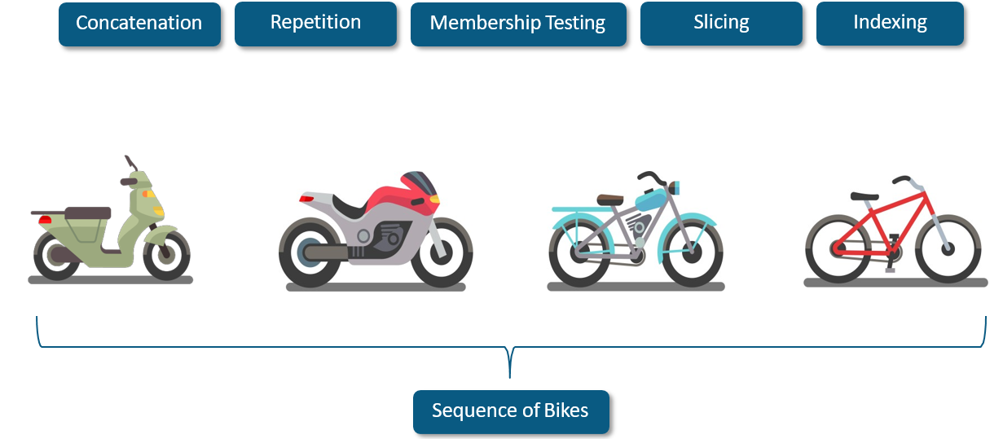

**Example: Sequence Operations**

list=[**"Marketing"**,**"Content Designing"**,**"Sales"**]

print(list)

*#Concatenation* print(list+[**"Python"**,**"Hadoop"**])

*#Repetition*

print(list*2)

*#Membership Testing* print(**'Marketing' in** list)

*#Indexing*

print(list[2])

*#Slicing*

print(list[0:2])

**What are types of Sequence in Python?**

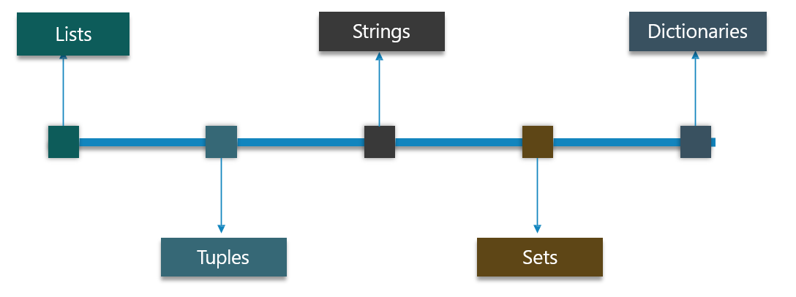

* Types of Sequences in Python
  + Lists
  + Tuples
  + Strings
  + Sets
  + Dictionaries

## 4.2 String Manipulation

**What is String?**

We can create them simply by enclosing characters in quotes.

Strings are amongst the most popular types in Python

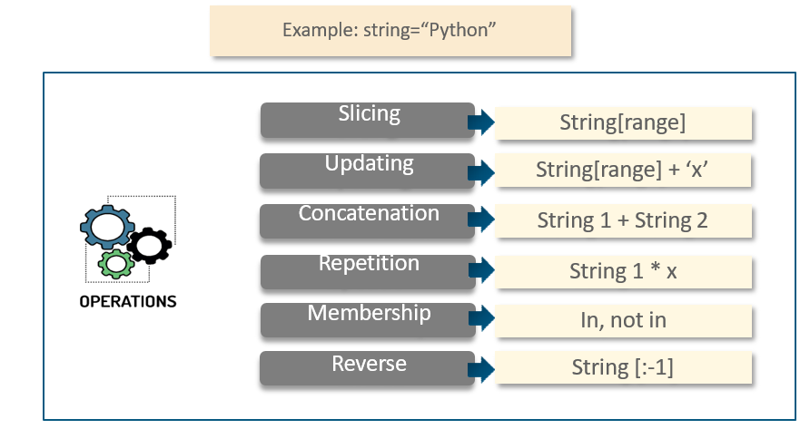

**Example: String**

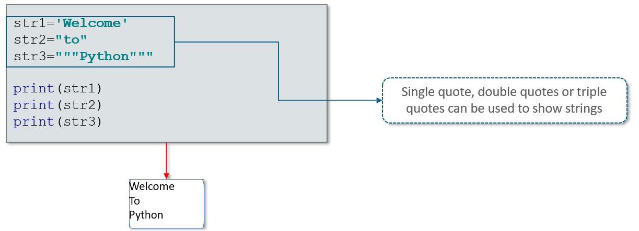

**String** **Operations**

Single quote, double quotes or triple

quotes can be used to show strings

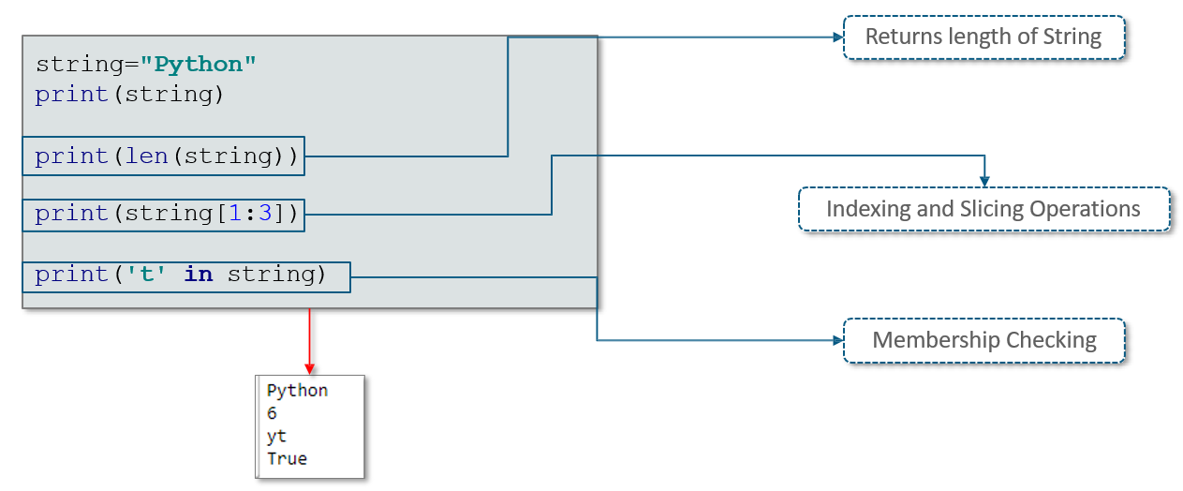

**String Formatting Operators**

|  |  |
| --- | --- |
|  |  |
| **Operators** | **Conversion** |
| %c | character |
| %i | signed decimal integer |
| %u | unsigned decimal integer |
| %o | octal integer |
| %x | hexadecimal integer lowercaseletters |
| %e | exponential notation withlowercase′e′ |
| %f | floating point real number |
| %g | the shorter of %f and %e |

**Example: String Formatting Operators**

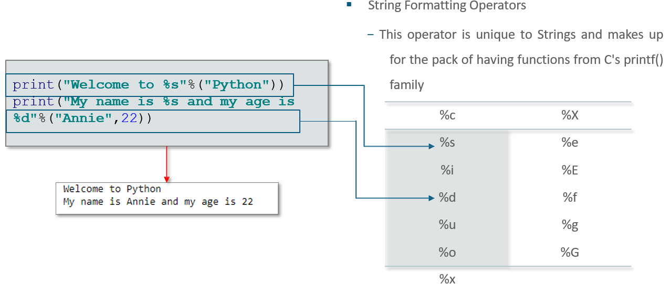

**Built in String Methods**

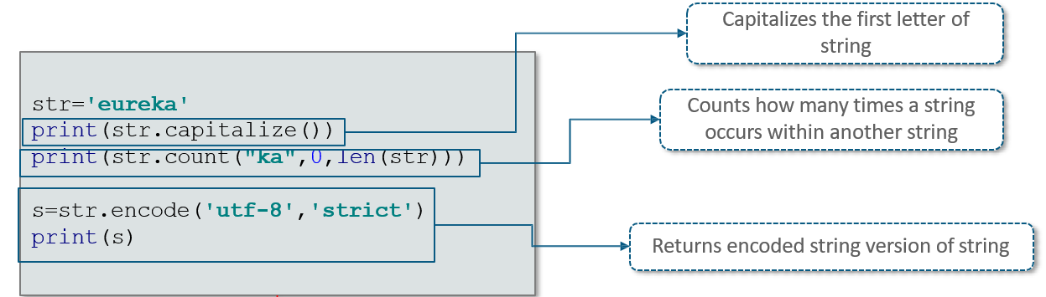

Eureka

1

b, eureka

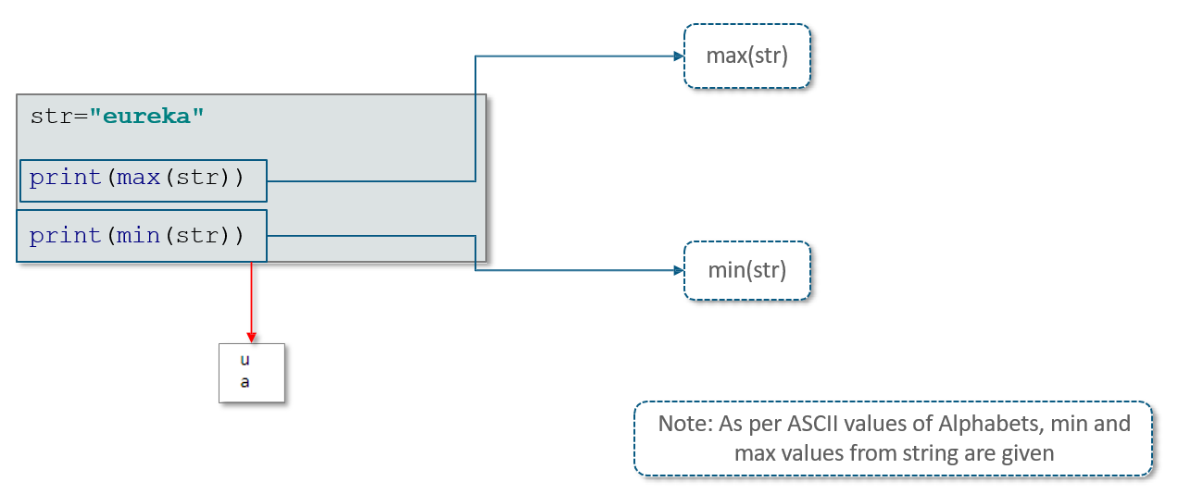

**More String Methods…**

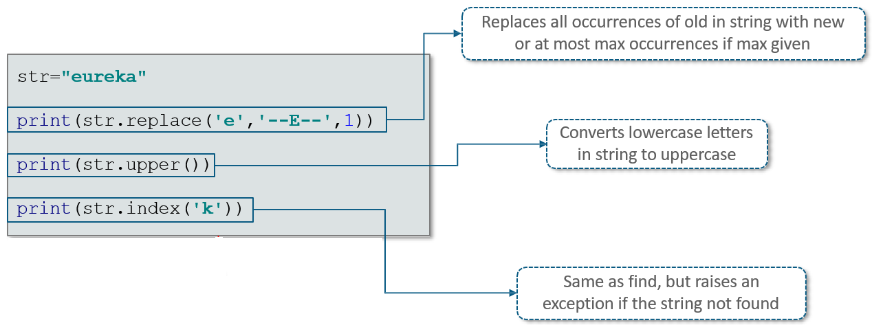

--E--ureka

Eureka

4

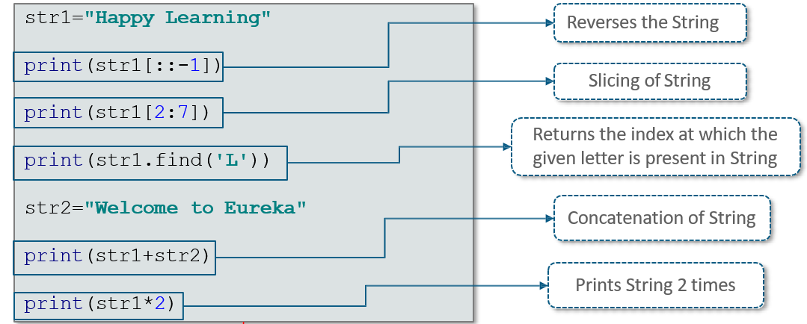

gninraeL yppaH

ppy L

6

Happy Learning Welcome to Eureka

Happy Learning Happy Learning

